Success at Last!
by Fay Bussgang

For several years now, I have been searching for some evidence that the family of my grandmother, Fajga Torończyk, whom I was named after, lived in Włocławek, Poland, a city on the Vistula River about 140 km. northwest of Warsaw. According to my father, my grandmother’s father, Chaim, ran a modern cheder for older boys there. Although my husband, Julian, and I had found information about other Torończyks during two previous trips to the archives in Włocławek, we could find no trace of my grandmother’s family.

In 1992, during our first trip to the Włocławek Archives (see Avotaynu, Winter 1992), we were told that all Jewish metrical records (birth, marriage, death) in Włocławek had been destroyed. When I expressed great disappointment, we were told about something called spis mieszkańców/księgi ludności (residents list), a listing of all the inhabitants of the town. In large bound volumes, each household was shown on a separate page, with dates and places of birth of all its members, names of parents, occupation, etc. On that first visit, the archivist asked whom we were looking for and said that the staff would bring us the appropriate volumes. They would not allow us to see the indexes.

They brought us several volumes with Torończyk and Toruńczyk households. In Warsaw, we had just met an elderly woman by the name of Emilia Toruńczyk who had grown up in Włocławek. She had told us that she knew of Torończyks in Włocławek, but that she was under the impression that the Toruńczyk and Torończyk families were not related. Nonetheless, I copied down information about her family that we found in the residents lists, as well as all the Torończyks I found, none of whom I could place at the time. Some records were in Russian, and the archivist helped us with the names and dates.

My grandmother’s brother, Natan Torończyk, had lived in Łódź. On our next trip to Poland, in 1993, I found in the Łódź Archives (where listings of the city’s inhabitants are on large cards rather than in bound volumes), a resident’s card with Natan’s name on it that showed that he was born in Nieszawa, a small town not far from Włocławek. I had not heard of Nieszawa before, but this made me think that perhaps my grandmother’s family was from Nieszawa and not Włocławek at all. Since we often say that we are from Boston rather than Lexington, it was possible that my father had just given the name of the nearest city.

We learned that many Jewish metrical records from Nieszawa have survived and are kept in the regional archives in Włocławek. We thus returned to the Włocławek Archives in 1993 with high hopes of finding not only Natan’s but also my grandmother’s birth record. Unfortunately, no such luck. However, I did find a marriage record of a Herszek Abramowicz Toruńczyk who married a girl from Nieszawa in 1861. The document stated that Herszek was born in Parzęczew, was then living in Lipno, and was the son of Abram Chaimowicz Toruńczyk and Ester Bine Wolfównej Widawska of Lipno. At first glance, I was not very interested in this document, but then I got to thinking.

Before coming to Poland on this trip, I had learned from a family friend that the father of my great-grandfather Chaim had divorced his first wife when his children were grown, married a much younger woman named Tekla, and had several more children (what a scandal that must have been!). However, the family friend didn’t know Chaim’s father’s first name.

In the one microfilm from Włocławek that the Mormons have in their collection, a marriage book from 1929, I had discovered the marriage record of a Szmul Torończyk that included a copy of his birth record from 1865 in Lipno, a small town north of Włocławek. The birth record showed his parents as Abram and Tekla, and Abram was at least twenty years older than his wife. How many Abram Torończyks could be married to a woman named Tekla who was many years younger? It seemed to me then that I had stumbled upon Chaim’s father. The Mormon record showed that this Abram Torończyk had previously lived in the town of Parzęczew before moving to Lipno.

I then looked more closely at this marriage document of Herszek Toruńczyk in the Nieszawa records. Herszek was the son of Abram, he was born in Parzęczew, and he now lived in Lipno. Could this Abram be the same Abram who later married Tekla? If so, this Ester Bine Wolfównej Widawska could have been his first wife. Then Herszek would have been the younger brother of my great-grandfather Chaim, and Ester would have been my great-great-grandmother. Mindful of what Emilia Toruńczyk, the woman we met in Warsaw in 1992, had told me, I was a little bothered by the fact that the spelling in the Nieszawa record was Toruńczyk.

However, we soon found other evidence that led me to believe that Toruńczyk and Torończyk were variations of the same name. Among the Nieszawa documents were the birth records of all the siblings of the grandfather of Emilia, and the name was spelled Torończyk. The records showed that her great-grandfather, Szlama, was born in Ozorków, a town northwest of Łódź and very close to Parzęczew, and that Szlama’s parents were named Chaim and Etta. I knew that Emilia’s father was named Chaim, probably after this Chaim, his great-grandfather. My great-grandfather was also Chaim. Who was he named after? Could it be the same Chaim?

In the marriage record of Herszek, his father’s name was Abram Chaimowicz. Chaimowicz means the son of Chaim. If Abram was indeed the father of my great-grandfather Chaim, and Abram’s father was also Chaim, then Abram obviously had named his son after his father. But how could I be sure that Abram’s father and Szlama’s father were the same Chaim? Szlama was born in Ozorków and Abram had lived close by in Parzęczew. Szlama went some distance away to Nieszawa, and Abram’s son, my great-grandfather Chaim, also went to Nieszawa (Łódź records showed his son, Natan, to have been born there). The Włocławek residents lists we’d seen the year before showed that Szlama’s son, Emilia’s grandfather, had lived in Włocławek. According to my father, his grandfather, Chaim, also lived in Włocławek. To have followed such similar paths, the families must have been related. My head was spinning, but it all seemed entirely plausible.

Since we were already in the Włocławek Archives and there was some time left, I decided to recheck some of the Torończyks we’d seen the year before in the Włocławek residents list. The entries now made more sense to me, since some of them were children of Abram and Tekla, thus the younger half-siblings of my great-grandfather.

One of the resident list entries, which I hadn’t seen the year before, was of a widow named Małka Toruńczyk, living alone. She was born in Ozorków in 1837, her parents were Lejbuś and Chaia Rozenblum, and she died in 1911. I copied down the information although I had no idea who she was, and I was still thinking about the other discoveries.

A short while before this second trip to Włocławek, we had been introduced to Emilia’s younger cousin Henryk and his family, who live not far from Warsaw. They had invited us to their house for dinner, and we hit it off very well, though at that time, we had no idea whether we were related or not. Now, after my discoveries in the archives, I was beginning to think that Henryk and I were fourth cousins!

Later, in 1995, I got the death record of my grandmother’s brother, Natan, from the Łódź civil records office. It gave his mother’s name as Ester Małka Torończyk, no maiden name. I began to wonder if the Małka Rozenblum Toruńczyk that I had glossed over in the Włocławek residents list in 1993 could have been Ester Małka, Chaim’s wife, and my great-grandmother. Perhaps she dropped the name Ester because it was the name of her mother-in-law! My father had mentioned visiting his grandmother in Włocławek when he was about eighteen years old, which would have been in 1908. Since Małka lived until 1911, it seemed entirely possible.

I wrote to the Włocławek Archives to see if there was any information that I had failed to copy down which might tell me who Małka’s husband was. I received no answer. I was told later that they never received my letter.

After the Jewish Genealogical Seminar in Paris this summer (1997), Julian and I again went to Poland and to the Włocławek Archives. I could hardly wait. I had copied down the reference to Małka Toruńczyk as Volume IV, p. 423. I asked to see it. The archivist told me that there were Volume IV’s in every series of the residents lists, and there were several series. I had failed to copy down the signatura number, the unique number given each item in the archives.

The archivists looked in the Volume IV’s of every series to no avail. They brought me other volumes with Torończyks and Toruńczyks. I was becoming more and more frustrated. The only volume I wanted to see was the one with Małka Toruńczyk in it. I was beginning to think that the three-hour trip from Warsaw had been in vain.

Finally, after her staff had carried so many heavy volumes up from the stacks, the director told us she could do no more. If we wished, we could come downstairs and look for ourselves. We went into the stacks, and for the first time, we were allowed to see the books containing the indexes. The staff gave me indexes to volumes after 1918. Małka Toruńczyk had died in 1911. I kept begging for earlier and earlier indexes, which they finally brought. The first one showed me nothing. In the second, I found an entry, written in Russian. There, very clearly, were listed four Toruńczyks–Chaim, Małka, Etta, and Rivka, all with the same reference! I stared in disbelief!!!

I asked for the volume referred to in the index, and they brought it. There, on one page was a mountain of information. Chaim Toruńczyk, born 1825 in Ozorków. His parents were none other than Abram and Ester, the same as of Herszek in the Nieszawa document. Chaim’s profession was melamed (Hebrew for teacher). In 1890 the family had moved to Włocławek from where? Nieszawa. Everything fit. The entry also showed that my great-grandfather Chaim had died in 1898, so he lived in Włocławek only eight years.

Now that I knew that Małka was indeed my great-grandmother, I could add her and her parents, Chaia and Lejbuś Rozenblum, to my family tree. And because Chaim’s parents were confirmed as Abram and Ester in the residents list, Herszek must have been Chaim’s younger brother, and Chaim’s mother must have been Ester Bine Wolfównej Widawska. I could add not only her name but also that of her father, Wolf Widawski (Wolfównej = daughter of Wolf). Furthermore, since Abram was Abram Chaimowicz, son of Chaim, I knew that my great-great-great-grandfather was named Chaim.

And what about Emilia and Henryk’s branch of the family? According to the residents list, my great-grandfather, Chaim, was born in Ozorków, the very same town where Szlama, the great-great-grandfather of Henryk was born. I was now convinced that my great-great-grandfather, Abram, and Henryk’s great-great-grandfather, Szlama, were sons of the same Chaim and therefore brothers. And if that were so, then the elder Chaim’s wife, Etta, was my great-great-great-grandmother.

That wasn’t the end of the wonderful information gleaned from this one entry. The two additional names listed with Chaim and Małka were Etta and Rivka. These were my grandmother’s sisters, whose names I knew as Yitala (a diminutive of Etta) and Rivka. Perhaps Etta was named after her great-grandmother mentioned above. The entry gave the date and place of Etta’s and Rivka’s births, information that I had not known before. I was thrilled to see that next to the sisters’ names, at a later date, had been entered the names of the men they married and the towns where they came from. I had previously had no clue as to whom the sisters had married and no way of tracing their descendants. Etta continued to live in Włocławek, and I was able to find her and her husband’s names in a later series of the residents lists and learn the names of their four children. It was astonishing! Finding this one listing of my great-grandparents had enabled me to tie together an enormous amount of information!

With the number of the house from this entry, the archivist was able to find the entry in the next series, which is the one I had copied down before on Małka Toruńczyk. The problem in finding it? It turned out that it was Volume IX. I rechecked my original notes. I had copied it carelessly and read the X as a V. Nonetheless, since they had originally found that entry in the index, why, even though they were very cooperative and helpful, could the staff not find it again? And why, had they not, in the first place, found this marvelous entry of my great-grandparents that I found so easily once I had the right index? Ah, the mysteries of archives!!

I don’t know whether it was chance or perseverance that made this discovery possible, but at any rate, it was worth the whole trip!

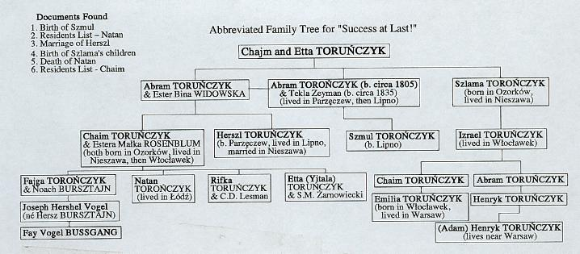
Abbreviated Family Tree

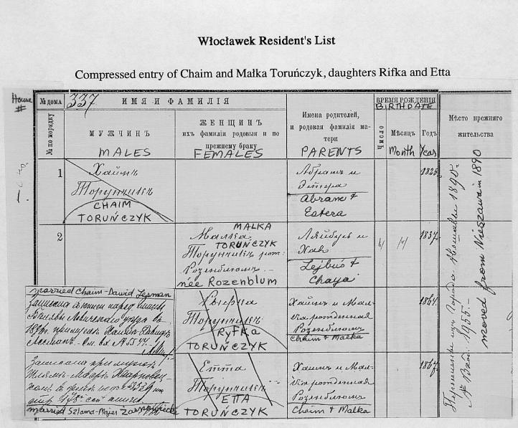

Originally published in Mass-pocha (Fall/Winter 1997)

